# Media Analysis - Is the Arab world ready for the uncertain age of AI-powered web tools

## Short Summary

The article focuses on ChatGPT, large language models capable of mimicking human-like writing but lacking creativity, emotional intelligence, and skepticism it highlights the potential of complementary AI models like reinforcement learning, generative adversarial networks, and symbolic AI, while stressing the importance of maintaining human trust and judgment in AI's expansion.

## Summary

1. In the dynamic realm of Artificial Intelligence (AI), ChatGPT, a model based on large-language models (LLMs), has emerged as a significant player with immense potential and considerable anxiety surrounding its impact. Developed by OpenAI, ChatGPT is trained on vast amounts of textual data, enabling it to generate human-like text in response to a wide range of prompts.  
2. One of the key strengths of ChatGPT lies in its ability to simplify and engage users with content creation tasks such as writing social media posts, blog entries, business plans, reports, emails, presentations, legal documents, medical reports, summaries, responses to customer inquiries, and complaints. It can also assist in entertainment, medical diagnosis, and even provide unbiased news coverage when fact-checked appropriately.  
3. However, the widespread use of ChatGPT is not without challenges or concerns. The anonymity it provides can lead to cheating during examinations, as seen at institutions like Sciences Po in Paris and Minnesota University Law School. This has prompted some educational bodies to reintroduce paper-based tests or ban the use of ChatGPT on their networks.  
4. Critics also argue that while AI can be useful for tasks requiring pattern recognition, it lacks the creativity, emotional intelligence, and critical thinking skills that human writers possess. As such, human oversight remains crucial in ensuring accurate and trustworthy information, as highlighted by Dr. Scott Nowson from PwC Middle East's artificial intelligence team.  
5. Moreover, the diverse applications of AI extend beyond social media and business documents into areas like entertainment, medical diagnosis, and even driving vehicles through advanced self-driving car technology. The potential for innovation is enormous, with forecasts valuing AI investments in trillions of dollars globally.  
6. Despite its immense investment potential, the future of AI remains uncertain. While there's optimism that AI will augment human capabilities and enhance efficiency, there are also concerns about job displacement due to automation and ethical implications surrounding privacy, security, and decision-making processes. Therefore, fostering trust in AI solutions through transparency, robust regulation, and ongoing education becomes paramount for the safe expansion of its use across various sectors worldwide.

## Question 1:

How do the media in this article frame the public discussion about ChatGPT? Are there certain **metaphors** that keep cropping up?

The media frames the public discussion about ChatGPT using metaphors that describe AI as a 'digital scribe,' emphasizing its capacity to assist humans rather than replace them. This is often framed by describing large-language models like ChatGPT as 'machines for matching patterns,' highlighting their automated and rule-based nature. Additionally, the media portrays AI solutions as tools that enhance human capabilities, acknowledging human limitations in relation to AI abilities. Key metaphors include comparing AI to a digital scribe that aids humans in tasks such as content creation, expressing it as an enhancement rather than a replacement for human intelligence, and emphasizing the unique strengths of human creativity, emotion, and perspective.

## Question 2:

Which role does or might the Arabic World play in the development of Artificial Intelligence? Answer with 'Not mentioned' if not applicable.

Not mentioned

## Question 3:

Which use cases of Artificial Intelligence are helpful for the Arabic world based on this article?

Content creation and assistance, Educational institutional challenges due to cheating prevention, Reinforcement learning, generative adversarial networks, symbolic AI

## Question 4:

What is the final message of the article that the author wants to convey? Keep your answer short and precise!

AI has significant potential but must be used responsibly, considering both opportunities and challenges.

## Sentiment

The sentiment is <20.0>

neutral

## Entities

James Webb, Sam Altman Year, Noaman Sayed, Elon Musk Serve Start Board, Reid Hoffman, Omar Sultan Al Olama Take, Jenna Burrell, Spearhead Uae Expand Digital Economy Middle East Project, Sciences Po School Paris, Dan Milmo Alex Hern Tech, Jumana Al Tamimi, Https Medium Arab News Country, Uk Guardian Newspaper Say, Initial Investment Firm Worth Billion Billion Mean Company Value, Research Data Society Independent Non Profit Research Organization Base California Say People Need Chatgpt, Marketing Professional Redundant Technology, Burrell Say, Peter Thiel Tesla, Chatgpt Spur Google Management, Arab News Leap Technology Conference, Linkedin Co, Multinational Tech Corporation Microsoft

## Topic Clusters

### Cluster: 1. AI Impact on Job Market

Arabic articles discussing potential job displacement due to automation, Discussions on reskilling and upskilling workers in response to AI integration

### Cluster: 2. Ethical Concerns about AI

Investigations into AI's potential misuse or bias, Debates on the moral implications of creating sentient machines

### Cluster: 3. Arabic Societies Adapting to AI

Reflections on how AI is shaping social structures and norms in the Middle Eastern context, Case studies on AI implementation for public services

### Cluster: 4. Legal Frameworks and Regulation

Analyses of existing laws or proposed legislation concerning AI use, Discussions on international cooperation for AI regulation

## Word Clouds

### Wordcloud of content

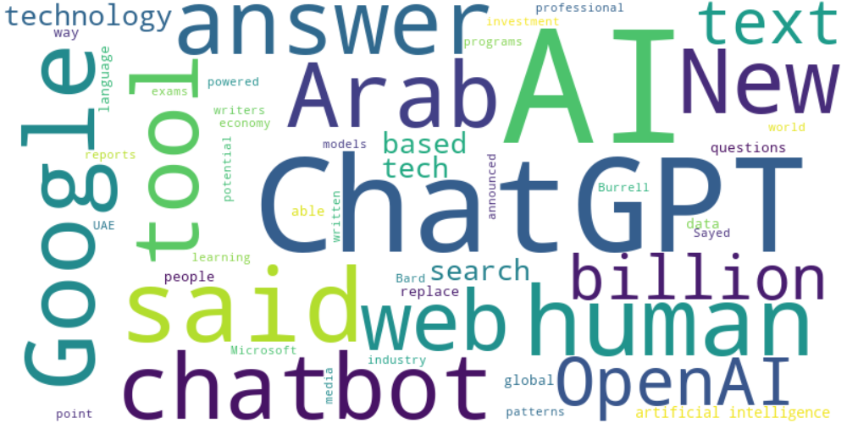

Top 10 words:

- AI: 25  
- ChatGPT: 17  
- said: 9  
- human: 8  
- Google: 8  
- Arab: 7  
- web: 6  
- intelligence: 6  
- OpenAI: 6  
- billion: 6

### Wordcloud of summary

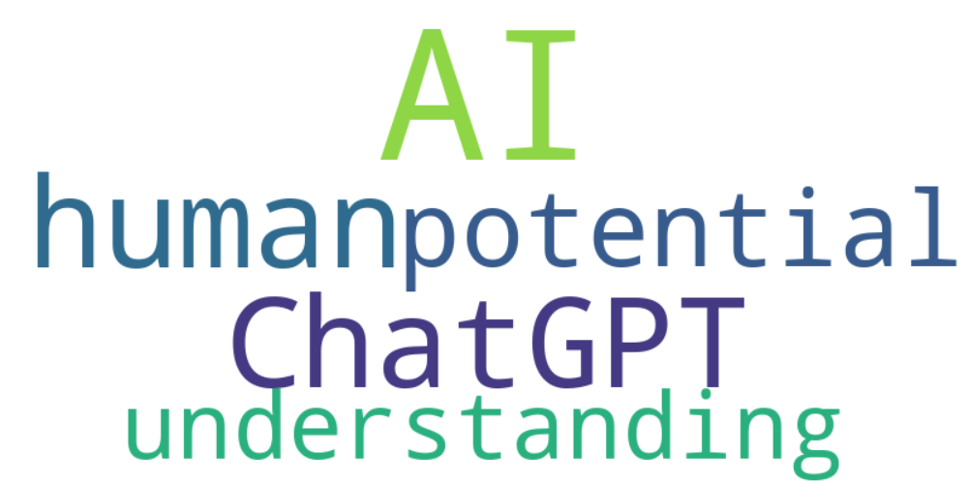

Top 10 words:

- AI: 7  
- ChatGPT: 5  
- human: 4  
- potential: 3  
- like: 3  
- medical: 3  
- use: 3